SPRING 2018
HIST 601 –ENTANGLED HISTORIES OF EUROPEAN EMPIRES, 1441-1830
UNIV 319- Wednesdays 3:30 to 6:20

Professor Silvia Z. Mitchell
mitch131@purdue.edu
UNIV 308. Office Hours: Wednesday after class and by appointment

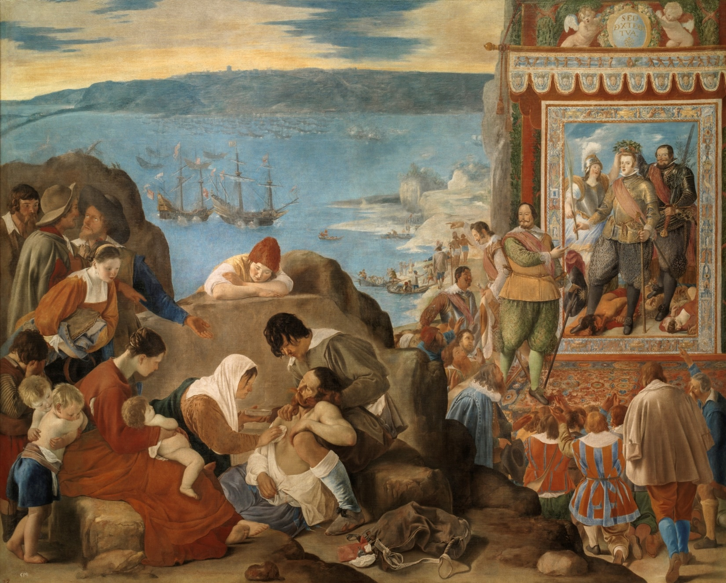
Juan Bautista Maino,
“The Recapture of Bahia,” 1634-1635

This course explores the history of European empires from the earliest Portuguese trading expeditions to North Africa to the revolutionary age that swept North, Central, and South America. The course seeks to break traditional national or imperial perspectives, emphasizing the interconnectedness of the political entities that shaped the world in early modernity. Students will gain a deep understanding of the transformations that occurred during these critical centuries, developing foundational content knowledge. A second and critical goal of the course is to familiarize students with existing and new historiographical approaches—Transnational History, Atlantic History, Borderland History, Imperial History, International History, and so on—to understand why and how practitioners may use one over the other.

The seminar is very broad chronologically and geographically. There will be extensive discussion of the English/British Empire as well as the Spanish, but also French, Dutch, and Portuguese. It starts early in 1441 and includes the revolutionary period in the Americas (1830s); emphasis will be on the 17th and 18th centuries.

Requirements and Grade Distribution:

- Five book reviews (700 to 1500 words). 10 % each + 10 % (I will double up your best one). Reviews will be based on a single monograph. You should describe the central argument/s, explore the author’s use of evidence and sources, and evaluate his/her contributions to the historiography. Because at your level, you may not be familiar with the significance of the work, you may consult—actually you are urged to consult—the reviews of the book (if available) by other historians. You may want to do this after you write the bulk of your review and add this information as a way of conclusion. (Just cite them in a footnote.) Reviews are due the day the monograph is assigned. Please submit via email before class. You can submit additional book reviews for extra practice or grade improvement (as many as you like). However, only forthcoming—rather than past—readings, however for additional reviews.

- Contribution to seminar discussions. 40 %. This will be based on attendance and participation. This is a small seminar, so if you have an emergency, please text me (as your emergency permits), 765-421-2908. I will be overseas a few times during the semester (check schedule below). We will not meet, but you are still responsible for completing the readings, which will be discussed in class the following class.

Class Schedule

January 17: Getting started
Readings on Entangled Histories, from an AHR (American Historical Review forum).

Eliga H. Gould, “Entangled Histories, Entangled Worlds: The English-Speaking Atlantic as a Spanish Periphery,” AHR 112: 3 (June 2007): 764-786.
Jorge Cañizares-Esguerra, “Entangled Histories: Borderland Historiographies in New Clothes?” AHR 112: 3 (June 2007): 787-799.
Eliga H. Gould, “Entangled Atlantic Histories: A Response from the Anglo-American Periphery,” AHR 112: 5 (Dec. 2007): 1415-1422.
Jorge Cañizares-Esguerra, “The Core and Peripheries of Our National Narratives: A Response from IH-35,” AHR 112: 5 (Dec. 2007: 1423-1431.

January 24: The Birth of the Atlantic

Excerpts from John Thornton, Africa and Africans in the Making of the Atlantic World, 1400-1800. Introduction and Chapter 1.

John H. Elliott, Empires of the Atlantic World: Britain and Spain in America, Introduction, Part I (we will divide the chapters).

Additional titles that may be of interest (these can be used to write book reviews)

Yuen-Gen Liang, Family and Empire: The Fernández de Córdoba and the Spanish Realm, Philadelphia: University of Pennsylvania Press, 2011.
Rolena Adorno, The Polemics of Possession in Spanish American Narrative. New Haven: Yale University Press, 2007.
Ida Altman, Emigrants and Society: Extremadura and Spanish America in the Sixteenth Century. Berkeley: University of California Press, 1989.
Jorge Cañizares-Esguerra, Puritan Conquistadors: Iberianizing the Atlantic, 1550-1700 (Stanford University, 2006).

January 31: Entanglements in the long 16th century.

John H. Elliott, Empires of the Atlantic World, (Part II).

Kris Lane, Pillaging the Empire: Global Piracy on the High Seas, 1500-1750, Introduction, Chapter 1: “Spain and the Sixteenth-Century Corsairs,” and Chapter 2: “Smuglers, Pirates, and Privateers: The Elizabethans.”

Additional:

Anthony Pagden, European Encounters with the New World, Yale University Press, 1993

Stephen Greenblatt, Marvelous Possessions: The Wonder of the New World, University of Chicago, 1991, 2017.

Fernand Braudel, The Mediterranean and the Mediterranean World in the Age of Philip II, 2 Vols. (University of California, 1996).

Charles Verlinden, The Beginning of Modern Colonization: Eleven Essays with an Introduction, trans. By Yvonne Freccero (Cornell University Press, 1970).

Rila Mukherjee, Networks in the First Global Age, 1400-1800 (Primus Books, 2011), Intro + selected chapters.

February 7 and 14: Living in an age of Imperial Entanglements

Choose from the following:

Daviken Studnicki-Gizbert, A Nation Upon the Ocean Sea, Portugal’s Atlantic Diaspora and the Crisis of the Spanish Empire, 1492-1640, Oxford University Press, 2007.

Alexandra Parma Cook and Noble David Cook, Good Faith and Truthful Ignorance: A Case of Trans-Atlantic Bigamy (Duke University, 1991).

James H. Sweet, Recreating Africa: Culture, Kinship, and Religion in the African-Portuguese World, 1441-1770.

Robert Harms, The Diligent: A Voyage Through the Worlds of the Slave Trade, Basic Books, 2002.

February 21, 28, March 7, 21, 28: The Seventeenth Century
(No class meeting on February 28; March 14 Spring Vacation)

Kris Lane, Pillaging the Empire, Chapter 3, 4, 5

Garrett Mattingly, “No Peace beyond What Line?” Transactions of the Royal Historical Society, Vol. 13 (1963), pp. 145-162.

Additional to choose from:

Wim Klooster, The Dutch Moment: War, Trade, and Settlement in the Seventeenth Century Atlantic World (Cornell University Press, 2016).

Karen Ordahl Kupperman, Providence Island, 1630-1641: The Other Puritan Colony (Cambridge University Press, 1993).

Carla Gardina Pestana, The English Conquest of Jamaica: Oliver Cromwell’s Bid for Empire (Cambridge, MA: Harvard University Press, 2017.

Donald G. Shomette and Robert D. Haslach, Raid on America: The Dutch Naval Campaign of 1672-1674 (Heritage Books, 2010).

Peter Earle, The Sack of Panama: Sir Henry Morgan’s Adventures on the Spanish Main (The Viking Press, 1981).

Jon Latimer, Buccaneers of the Caribbean: How Piracy Forged an Empire (Harvard University Press, 2009).

Nuala Zahedieh, “The Merchants of Port Royal, Jamaica, and the Spanish Contraband Trade, 1655-1692.” The William and Mary Quarterly, Vol. 43, No. 4 (Oct., 1986), pp. 570-593.

Roland D. Hussey, “Spanish Reaction to Foreign Aggression in The Caribbean to about 1680” The Hispanic American Historical Review, Vol. 9, No. 3 (Aug., 1929), pp. 286-302.

Christopher Storrs, The Resilience of the Spanish Monarchy, 1665-1700 (Cambridge, 2006).

April 4: The Pacific and Indian Oceans

Kris Lane: Pillaging the Empire, chapters 6 and 7

O. H.K. Spate, The Spanish Lake, (Australian National University, 1979).
(We will divide the chapters)

April 11-18: The Eighteenth Century

John H. Elliott, Empires of the Atlantic World, Part III

Eliga H. Gould, “Zones of Law, Zones of Violence: The Legal Geography of the British Atlantic, circa 1772.” The William and Mary Quarterly, Vol. 60, No. 3 (Jul., 2003), pp. 471-510

The French Colonial Empire, 1500-1800 (Digital Collection at the Newberry Library), http://dcc.newberry.org/collections/the-french-colonial-empire-1500-1800.

We will revisit some of the previous readings.

April 25: The Age of Revolutions

Ashli White, Encountering Revolution: Haiti and the Making of the Early Republic (Johns Hopkins University Press, 2010).

AHR Forum. Rafe Blaufarb, “The Western Question: The Geopolitics of Latin American Independence.” AHR 112 (June 2007): 742-763.

